Pivot Tables

A Pivot Table is way to present information in a report format. The idea is that you can click drop down lists and change the data that is being displayed. For example, choose just one student from a drop down list and view only his or her scores. Pivot tables are a lot easier to grasp when you see them in action. Here's the one we're going to create in this section:

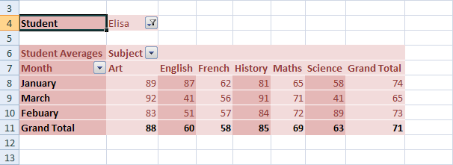

Look at Row 4. This shows that the student is Elisa. If we click Elisa's drop down arrow, we'll see this:

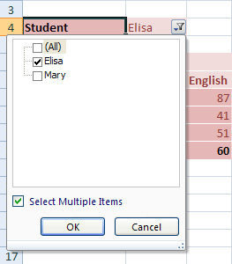

Now we have another student to select (we'll only use two students, for this tutorial). We could untick Lisa, and tick Mary instead. Then her scores would display.

The Subject and Month cells also have drop down lists. So we could view only January's scores, and just for Art and English, for example.

So this is a Pivot Table - a report that we can manipulate by selecting items from drop down lists. Let's make a start.

The first thing you need for a Pivot Table is some data to go in it. Instead of typing all the data out, you can simply grab the example. Go the intranet under Year 13/Unit 5 and Spreadsheet skills and download the excel file – PivotTable.xlsx

Once the spreadsheet is on your own computer, open it up. You should see this (If you get a warning across the top, click on Enable Editting):

It should look like the following:

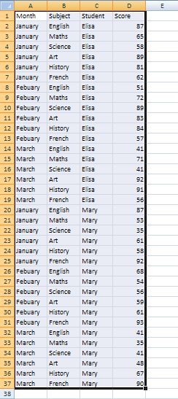

Highlight the data that will be going in to your Pivot Table (cells A1 to D37).On the Excel Ribon, click the **Insert** tab. From the Insert tab, locate the **Tables Panel**.

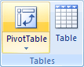

On the **Tables** panel click **Pivot Tables**. The **Create Pivot Tables** dialogue box appears:

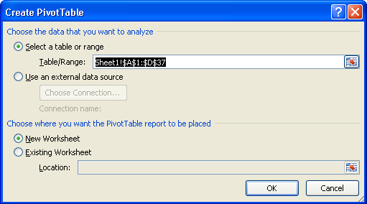

In the dialogue box above, the data that we highlighted is in the **Table/Range** textbox. You can select different cells by clicking the icon to the right of the Table/Range textbox. You can also specify an external data source, such as a text file, for the data in your Pivot Table.

We've selected a **New Worksheet** as the place where the Pivot Table will be placed. Click OK.

When you click OK, Excel presents you with a rather complex layout. The area on the right should look something like this one below:

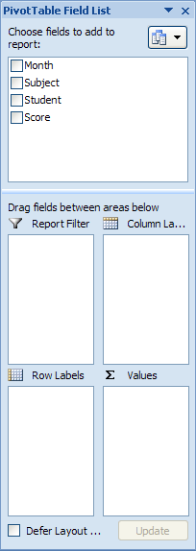

It helps to have a look again at what we're trying to create. Here's the completed Pivot Table again:



On the actual spreadsheet itself you should see the following:

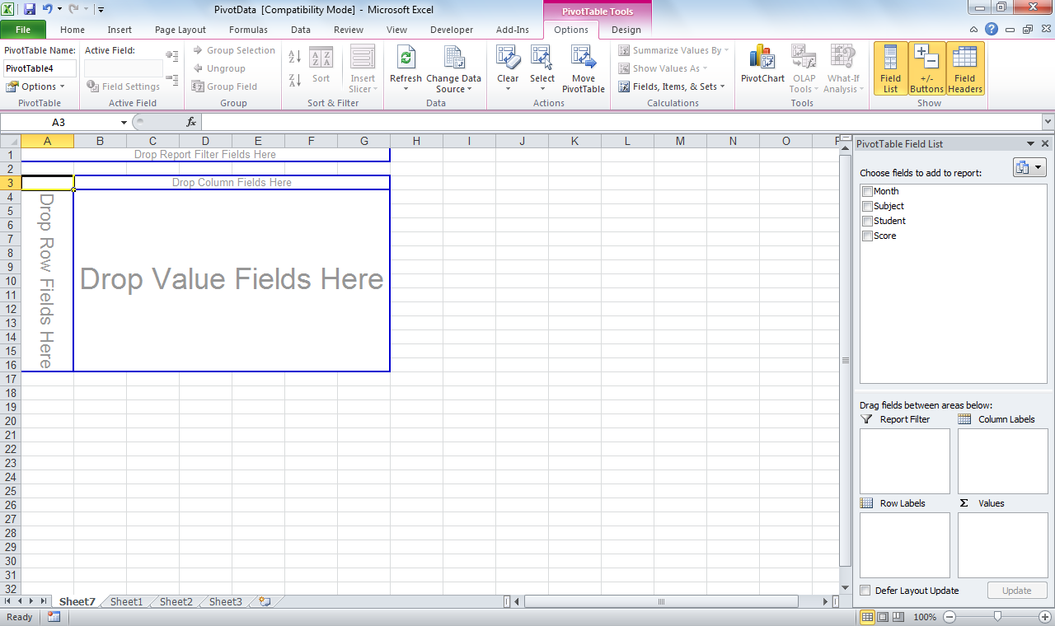

Now it is a case of just dragging the appropriate fields over to the appropriate place on the worksheet. Let’s do this one at a time.

1. We want to filter by student – so drag Student box over to where it says DROP REPORT FILTER FIELDS HERE

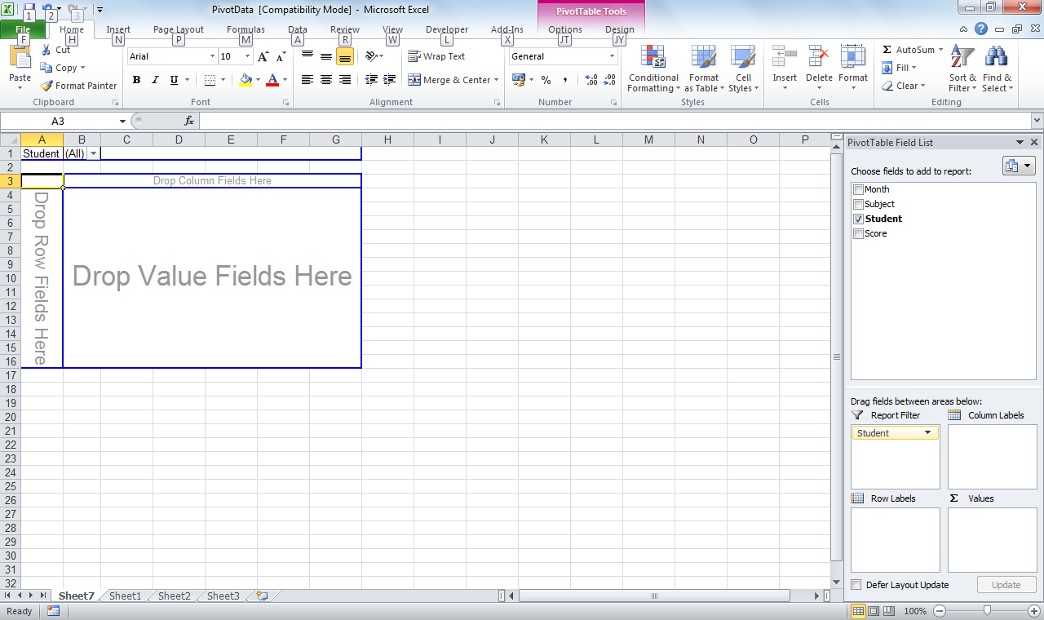

1. We want the rows to be Months – so we drag that over to where it says DROP ROW FIELDS HERE

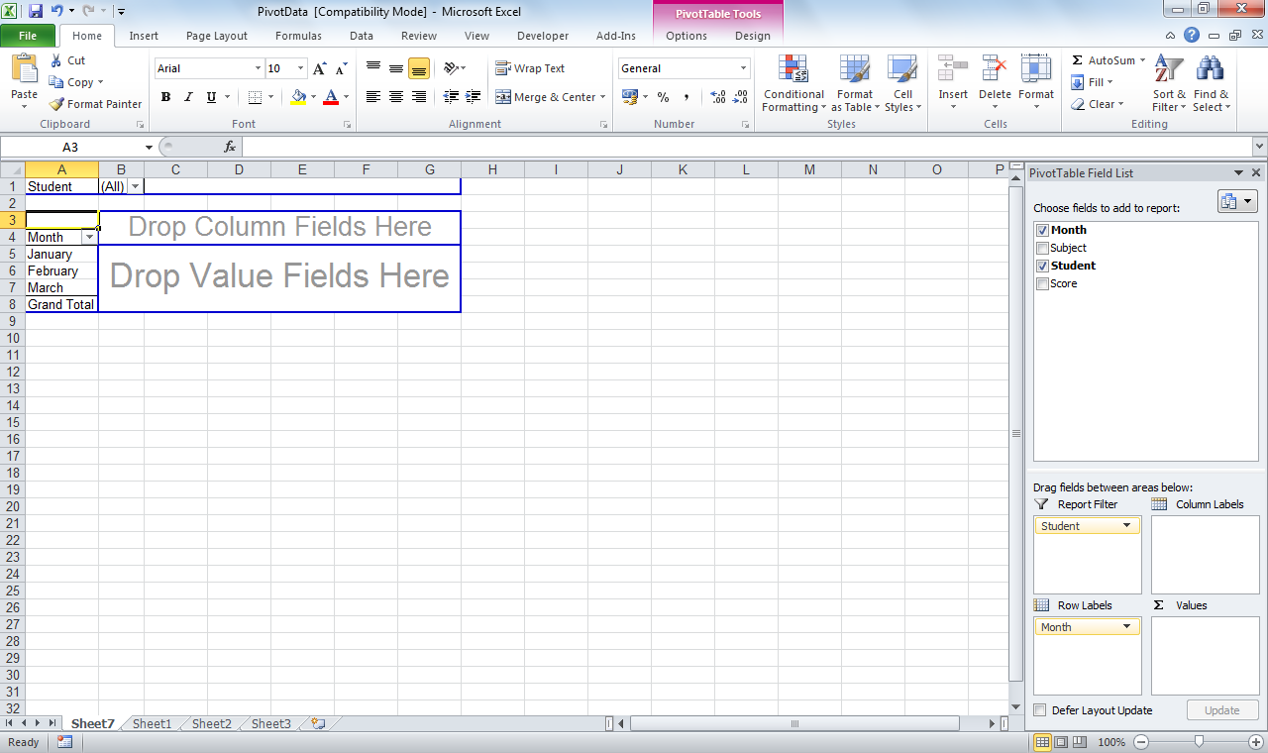

1. For the columns we want the subjects so we drag SUBJECTS over to where it says DROP COLUMN FIELDS HERE

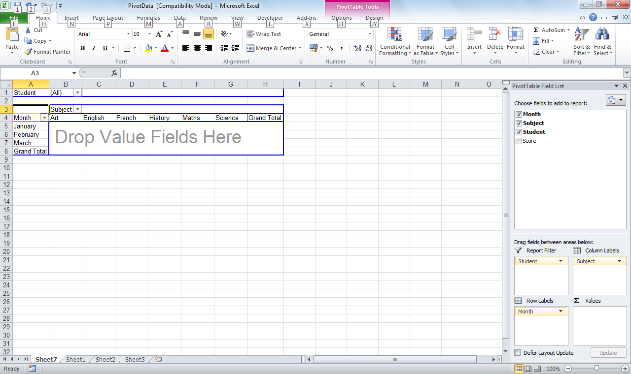

1. Finally you need to drag the SCORE box over to where it says DROP VALUE FIELDS HERE

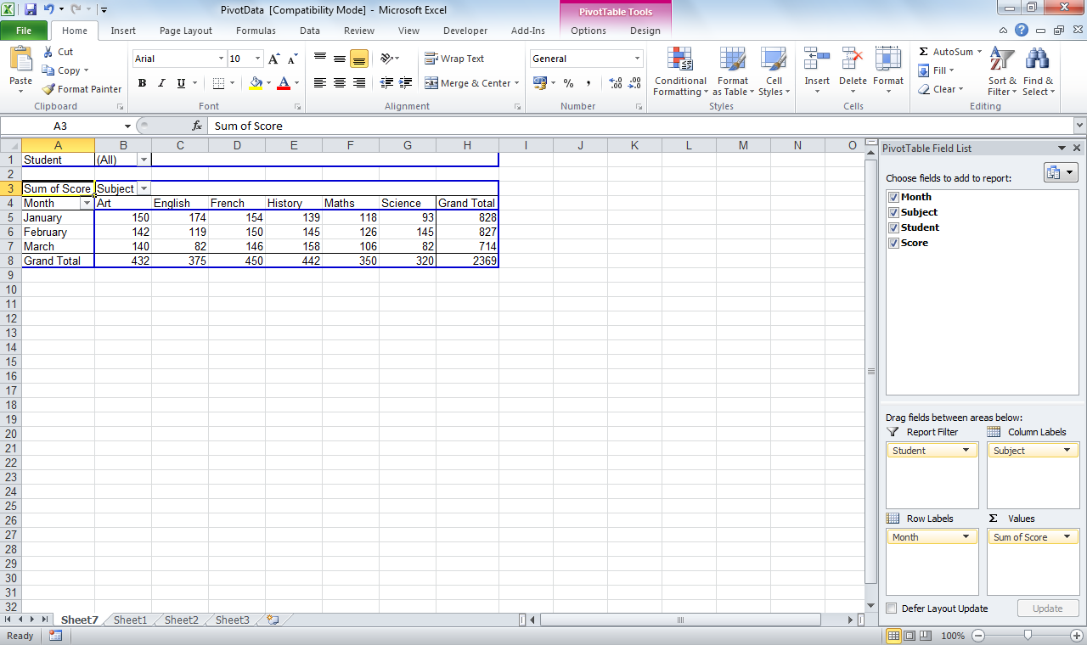

1. You can start filtering the table by students and also month and subject.

To change the Grand total from a SUM to an Average – simply select the item SUM OF SCORE from the column on the right side and select VALUE FIELD SETTINGS

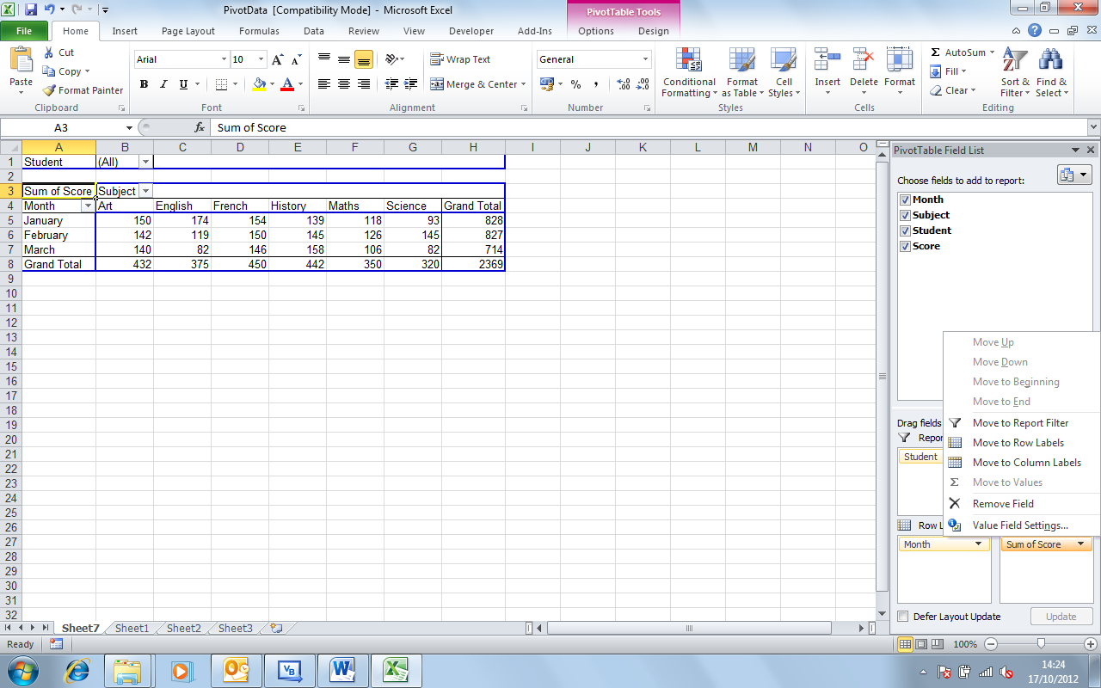

Select Sum of Score, right click and select Value Field Settings

Select Average from the box that comes up.

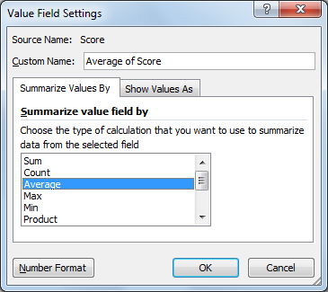

You can then reformat the cells to lose the decimals.

To change the colours of your table – by selecting it will bring up a Pivot Context ribbon – you can choose design and select a template from there.

If you wanted to make the table more interactive you could add macros to change the filters and then assign buttons to those macros.